

Cyberster Internship Program

Internship Report
TRACK: BLUE TEAM
NAME: MUHAMMAD RAZA
INSTRUCTOR: ABDULLAH ZIA
ROLL NUMBER: CSI-B1-121
WEEK 9: Advanced Browser Forensics, Shell/LNK Analysis, and Artifact Integration

1. Executive Summary
This report details the forensic triage and timeline reconstruction of a live Windows endpoint, focusing on user web activity and local file interactions. By extracting and correlating browser databases (Chrome/Edge) with Windows Shell artifacts (LNK files and Jump Lists), we reconstructed a unified chronological timeline of user actions.
Conclusion: The analyzed artifacts indicate structured, legitimate forensic and educational activity. The user downloaded forensic utilities, executed them locally, and accessed local development environments. No malicious extensions, unauthorized downloads, or suspicious file executions were detected.

2. Methodology & Evidence Integrity
Data acquisition prioritized evidence preservation. Browser processes were forcefully terminated prior to extraction to release active SQLite database locks and prevent data corruption.
- Acquisition: User profiles for Chrome and Edge were copied to a segregated C:\Forensics\BrowserData directory.

Chrome Profile:
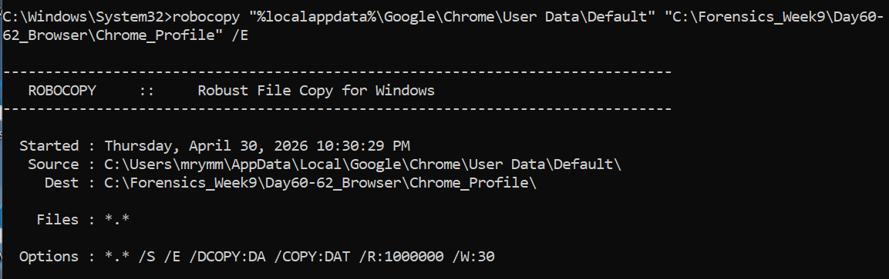

Edge Profile:
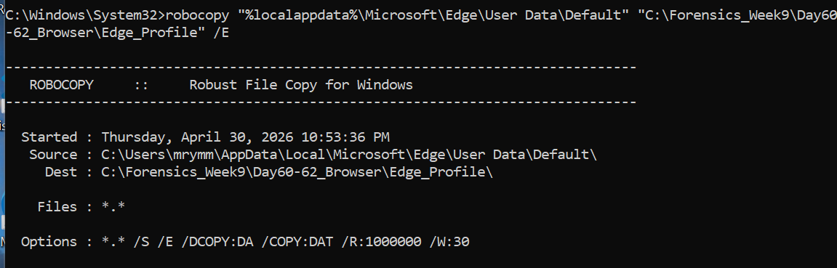
- Integrity Verification: SHA-256 hashes were immediately generated for critical SQLite databases (History, Cookies, Web Data) to establish a defensible chain of custody.

3. Part A: Advanced Browser Forensics
Browser artifacts were parsed using DB Browser for SQLite and NirSoft utilities to reconstruct web activity, downloads, and active sessions.

3.1. Web History & Download Activity
- Browsing Patterns: SQLite urls and visits tables confirmed traffic primarily directed toward educational resources, GitHub, and a local application (localhost - local phishing detection system).
- Downloads: The downloads table confirmed the deliberate acquisition of forensic and database tools. Identified files include:
  - LECmd.zip
  - JLECmd.zip
  - DB.Browser.for.SQLite-3.13.1-win32.zip

3.2. Cookies, Cache, & Extensions
- Session Data: Cookie analysis confirmed active, authenticated sessions corresponding to the observed web history.
- Cache: Extracted cache data revealed standard CDN assets and media associated with routine browsing.
- Extensions: An audit of installed browser extensions revealed only standard, benign add-ons. No unauthorized or malicious extensions were present.
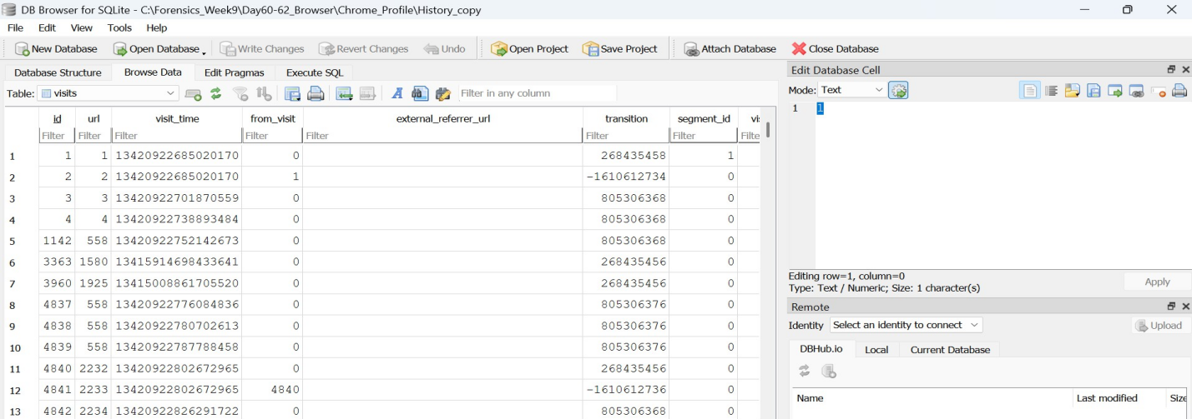

4. Part B: Shell & LNK File Forensics
To track what happened after files were downloaded, we analyzed Windows Shell artifacts, which record local file and application interactions.

4.1. LNK (Shortcut) File Analysis
Using Zimmerman's LECmd, LNK files located in the Windows\Recent directory were parsed.
- Findings: The parsed output verified the execution of the tools downloaded in Part A. Specifically, LNK metadata confirmed the extraction and execution of LECmd.exe and DB Browser. Additional LNKs pointed to local documents, including CodeAlpha.pdf.

4.2. Jump List Analysis
Using JLECmd, AutomaticDestinations and CustomDestinations files were parsed to review taskbar and pinned-item interactions.
- Findings: Jump List data corroborated the LNK findings, showing sequential access to the downloaded ZIP archives and the local localhost development environment.
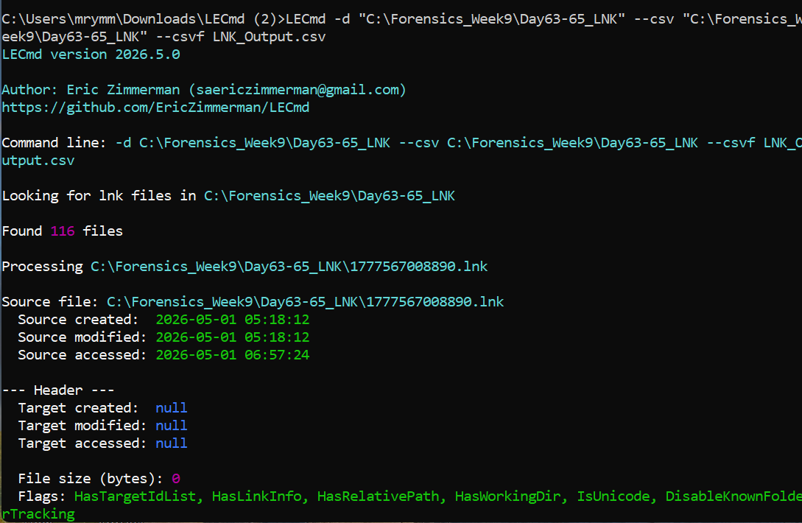

5. Part C: Timeline Generation & Artifact Integration
To provide a definitive sequence of events, browser timestamps (Webkit format) and Windows Shell timestamps (FILETIME) were normalized to UTC (PKT - 5 hours) and merged into a unified timeline.

5.1. Cross-Artifact Correlation
The integrated timeline successfully links external web activity to local system execution:
- Web Access: User navigates to a repository (Browser History).
- File Acquisition: User downloads LECmd.zip and DB Browser (Browser Downloads).
- Local Interaction: User extracts the ZIP archives (LNK / Shell activity).
- Execution: User launches the forensic tools and opens local PDF documents (LNK / Jump Lists).
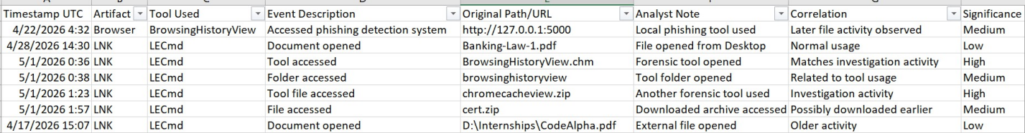

6. Conclusion
The integration of Browser and Shell artifacts successfully validated the host's activity timeline. Correlating the origin of a file (Browser) with its local execution (LNK/Jump Lists) confirmed that the user's workflow was exclusively related to educational and forensic analysis tasks. The investigative framework utilized in Week 9 is highly effective for tracing the lifecycle of a file from web-download to local-execution in an incident response scenario.

